**Technology Management & Innovation Centre**

**Team Research Agenda Major Research Projects Contact Us**

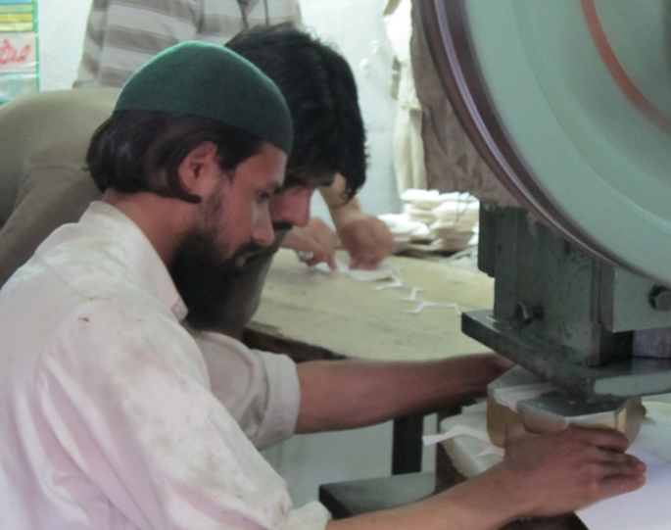

**Team:**

Dr. Azam Chadhry

Dr. Theresa Chaudhry

Tariq Raza

Saman Zahra Khan

**Research Agenda**

The Centre for Technology Management & Innovation was established in April 2015 with an aim to promote innovation, a key to growth for Pakistan’s future. The Centre is headed by Dr. Azam Chaudhry, Dean and Professor, Faculty of Economics, Lahore School of Economics.

The objectives of the centre are:

• Work on firm level research on innovation and productivity.

• Conduct surveys with international researchers on innovation and technology.

• Collaborate with the government on Policy based research focusing on technological upgradation in the manufacturing sector.

• Work with the Lahore Chamber of Commerce and other industrial organizations to promote technological innovation in Pakistan.

The centre is working on various exciting projects in the soccer balls industry, readymade garments sector and textiles. Currently, the research team is working on soccer ball project in which the team is looking at how subsidizing high quality inputs impact quality upgradation in the soccer ball sector, technology and innovation mapping project which aims to compare the technologies used in the soccer ball and readymade garments sector in Pakistan in comparison with the international market to see how far behind Pakistan is in adopting new technologies. Also, the research team is working to benchmark the productivity of garment factories in Pakistan.

Major contributions of the centre includes developing a cost saving technology for the soccer ball manufacturers in Pakistan resulting in 1% cost saving for the industry which operates with a very low profit margin of around 10%. This research has been jointly conducted by researchers at the Lahore School of Economics, Columbia University, University of Warwick and the Massachusetts Institute of Technology (MIT). Inspired by the spillover effect and benefits from this innovation, Government of Punjab has put in place an innovation fund to further promote innovation in other industries and sectors in Punjab.

**Major Research Projects**

**Major Research Projects:**

1. **Analysis of Technology in the Sialkot Soccer Ball industry Dr. Azam Chaudhry and Prof. Shamyla Chaudry**

The research team invented a new cutting technology in 2012 that reduces waste of the primary raw material. This cost saving technology was given to a number of soccer ball manufacturers in Pakistan in order to determine the factors affecting technology adoption in firms and technology spillovers between firms. Despite the apparent net benefits of the invented technology, adoption remained low even after 15 months. Thus the research team has also looked at how misaligned incentives between firms and employees can affect technology adoption. The incentive payment had a significant positive effect on technology adoption which shows that misalignment of incentives within firms is an important barrier to technology adoption.

Presently the research team is looking at how subsidizing high quality inputs impact quality upgradation in the soccer ball sector. In order to do this, the research team is giving up to up to Rs 600,000 in rexine subsidizes to a randomly selected group of football manufacturers. The project has been funded by IGC and PEDL and collaborators include Eric Verhoogen (Columbia University), Amit Khandelwal (Columbia University) and David Atkin (MIT).

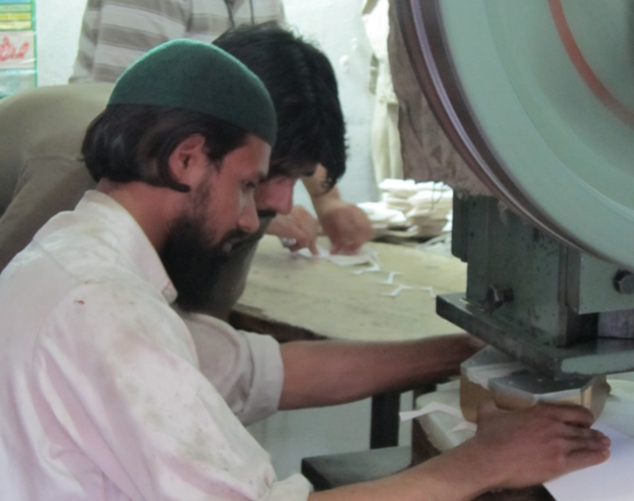

1. **Benchmarking of Productivity in Pakistan’s Readymade Garment Sector Dr. Azam Chaudhry, Dr. Theresa Chaudhry and Mahvish Faran**

The research team is working to benchmark the productivity of garment factories in Pakistan.

The pilot phase of the project will be used to understand bottlenecks to increasing productivity with the aim to develop productivity-enhancing interventions for the sector, to be evaluated through the method of a Randomized Controlled Trial (RCT).

The project has been funded by the IGC and collaborators include with Christopher Woodruff (University of Warwick) and Rocco MacChiavello (University of Warwick).

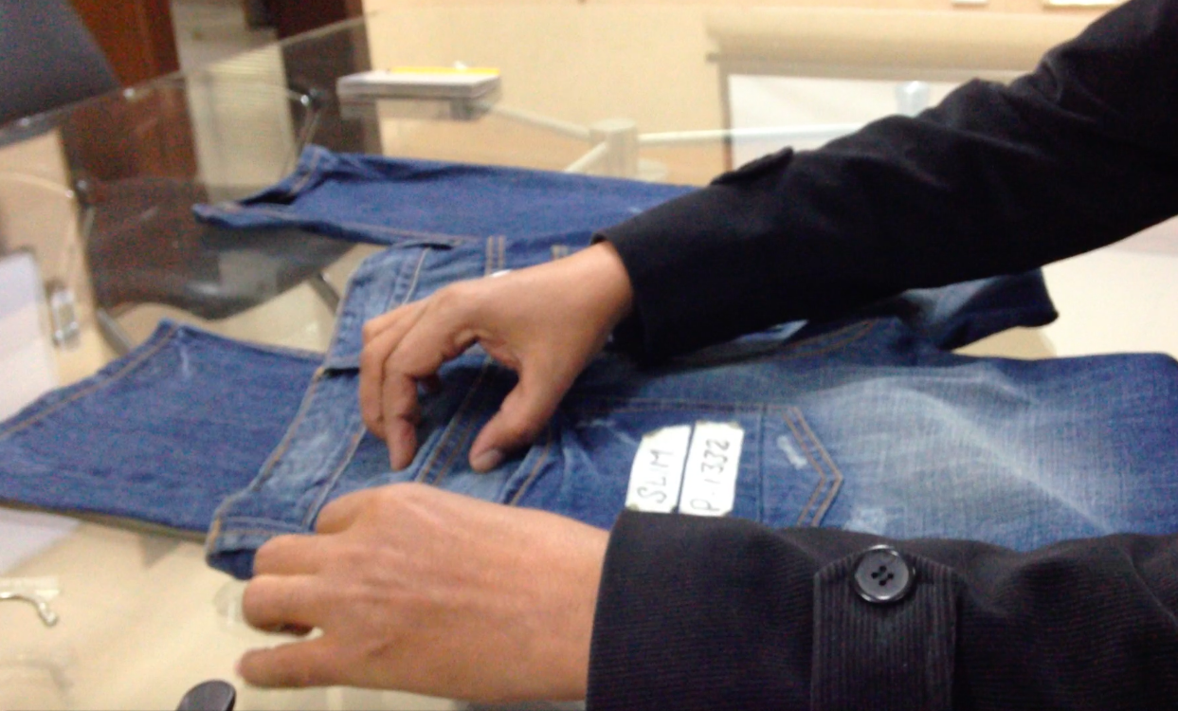

1. **Technology and Innovation Mapping Project Dr. Azam Chaudhry, Dr. Theresa Chaudhry and Mahvish Faran**

The aim of this initiative is to map the production process and the technologies used in the soccer ball and readymade garments sector. Then using this map, compare the technologies in these sectors with the forefront of international technologies to see how far behind firms in Pakistan are. Finally, the research team will see what incentives can be given to Pakistani firms to adopt new technologies (like financial incentives, supplying information about these technologies, providing assistance of adoption of these new technologies, etc.)

Collaborators include Rajah Rasiah (University of Malaya).

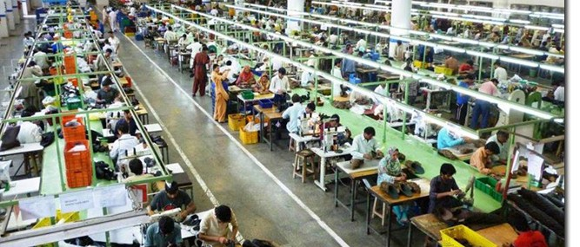

1. **Measuring Innovation in the Textiles Sector of Pakistan Dr. Waqar Wadho and Dr. Azam Chaudhry**

Textiles is the major manufacturing sector of Pakistan contributing one-fourth of industrial value added, employing 40 percent of industrial labor force, and on average 60 percent share of national exports.

In this project, they plan to study innovation activities of firms in the textiles sector of Pakistan during 2011- 2013. The survey will be completed by the end of 2015 across a sample of 500 textile firms in Punjab and Sindh and will measure both the technological (product and process) and the non-technological (organizational and marketing) aspects of innovation.

The project has been developed under the firm capabilities program of the IGC.

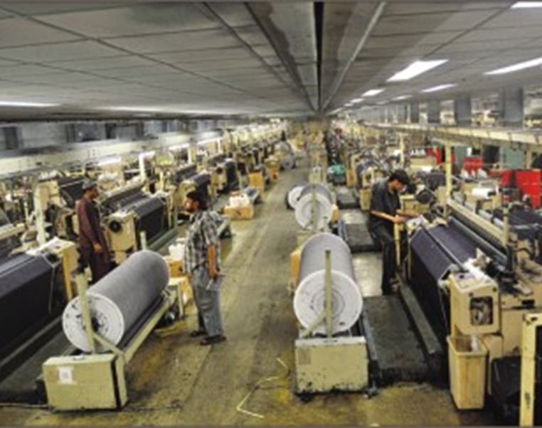

Contact Us:

Technology Management & Innovation Centre

**Address:** Intersection Main Boulevard Phase VI DHA, Burki Road Lahore 53200, Pakistan.

**Phone:** +92 42 36560936

**Fax:** +92 42 36560905

**Contact Person:**

**Email:**

**CONTACT FORM**

Top of Form

Send an email. All fields with an * are required.

**Name \***



**Email \***

**Subject \***



**Message \***



**Send copy to yourself**



**Captcha \***

|  |  |  |
| --- | --- | --- |
|  | Get a new challengeGet an audio challengeHelp | https://www.google.com/recaptcha/api/img/clean/logo.png |
|  | [Privacy & Terms](http://www.google.com/intl/en/policies/) | |

SEND EMAIL